**Matching Green C of E Primary School 2015-2016 Results**

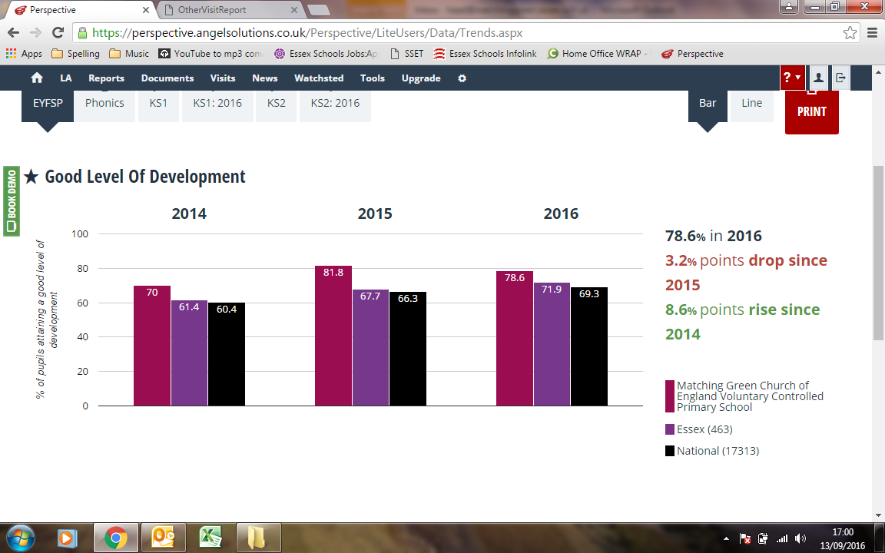**Key**

**End of Reception (EYFS) year results**

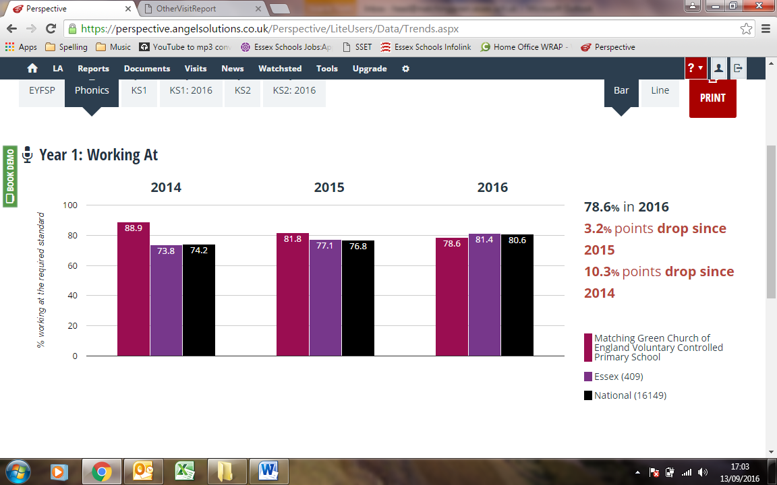**End of Year 1 Phonics Screening Test results**

**End of Key Stage One (Year 2) results for achieving expected standard or higher in reading**

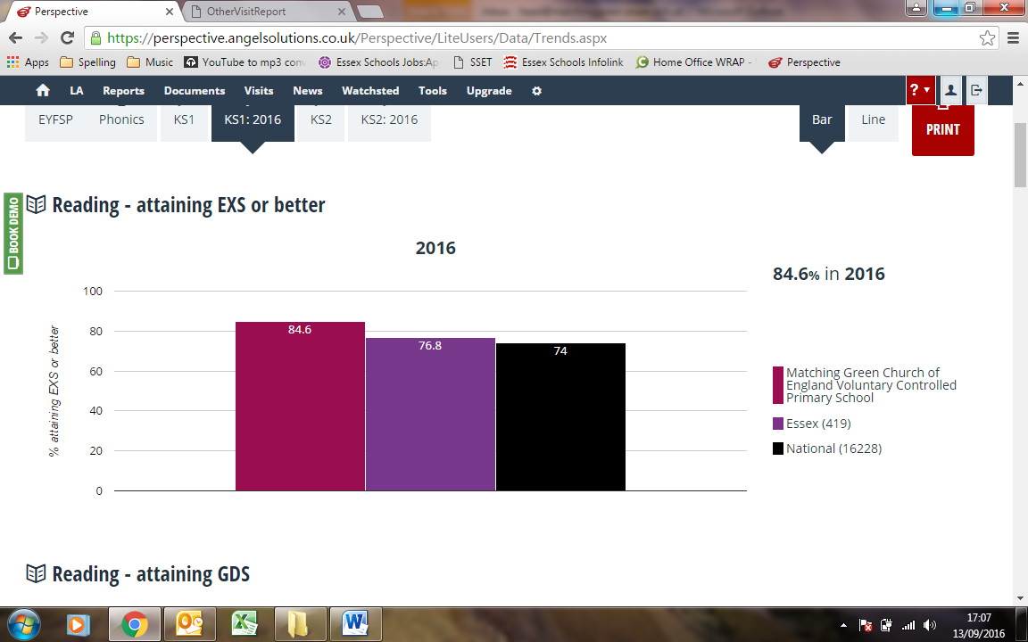

**End of Key Stage One (Year 2) results for achieving expected standard or higher in writing**

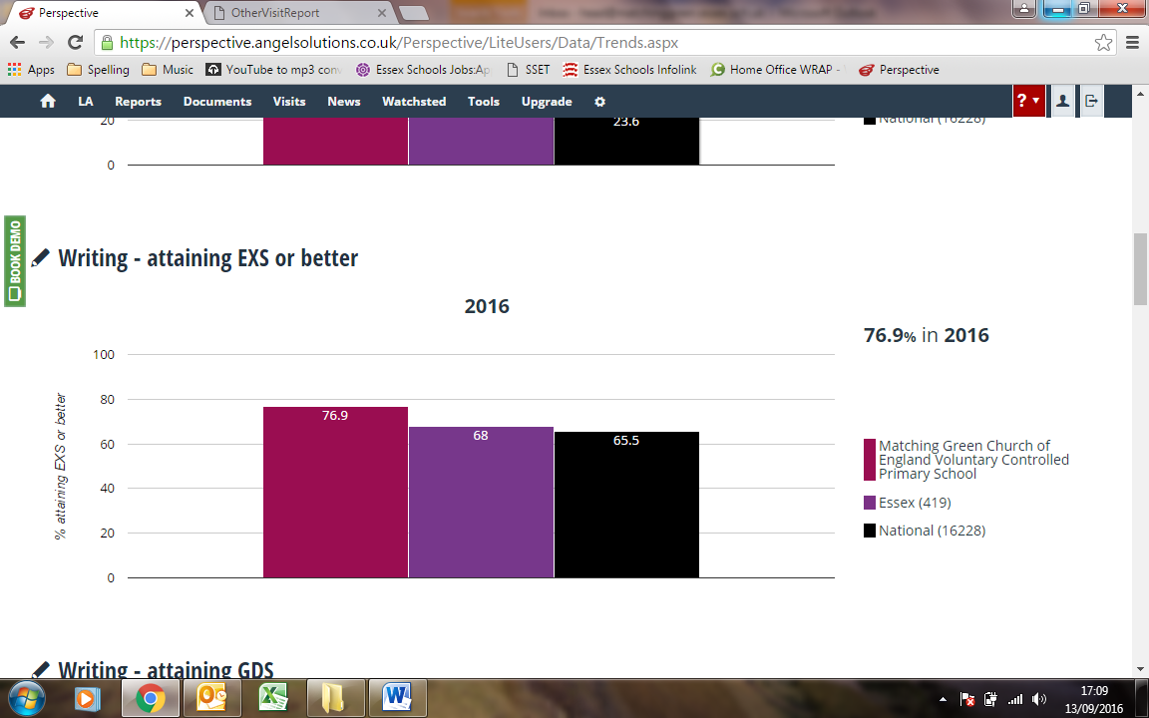

**End of Key Stage One (Year 2) results for achieving expected standard or higher in maths**

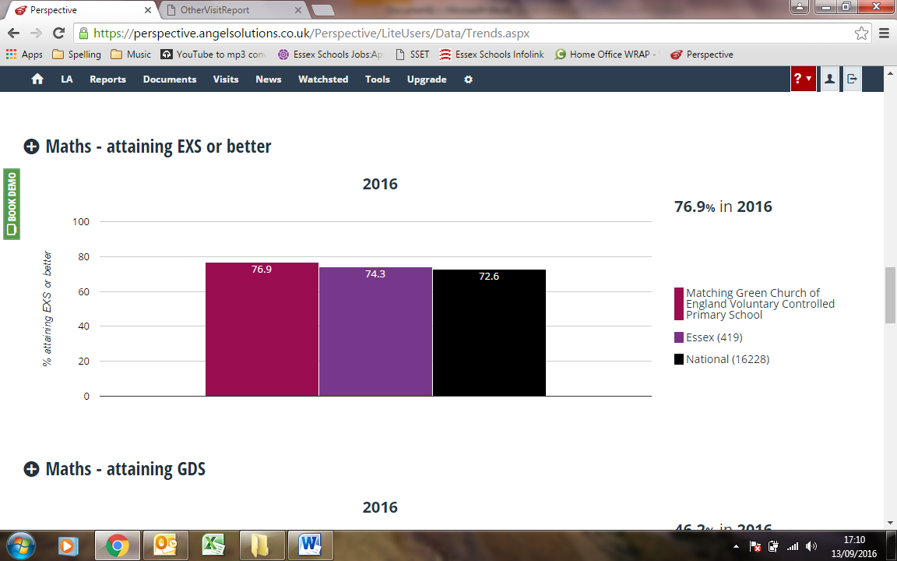

**End of Key Stage Two (Year 6) results for achieving the expected standard in reading**

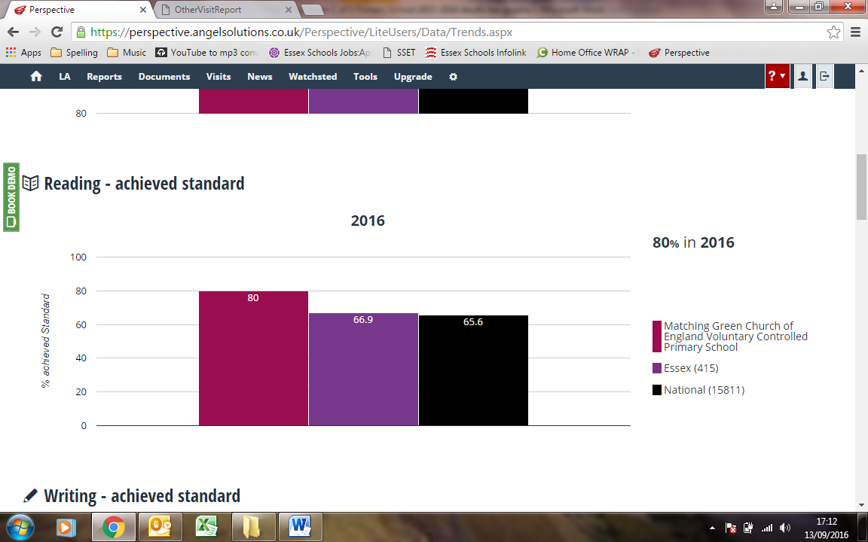

**End of Key Stage Two (Year 6) results for achieving the expected standard in writing**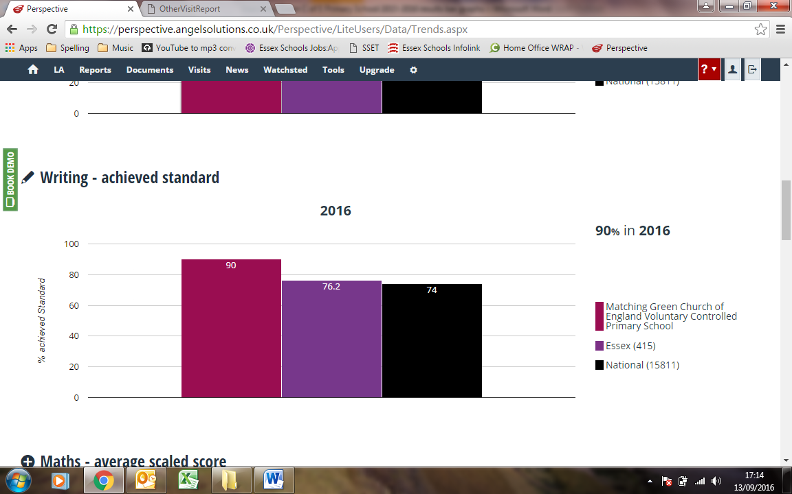

**End of Key Stage Two (Year 6) results for achieving the expected standard in mathematics**

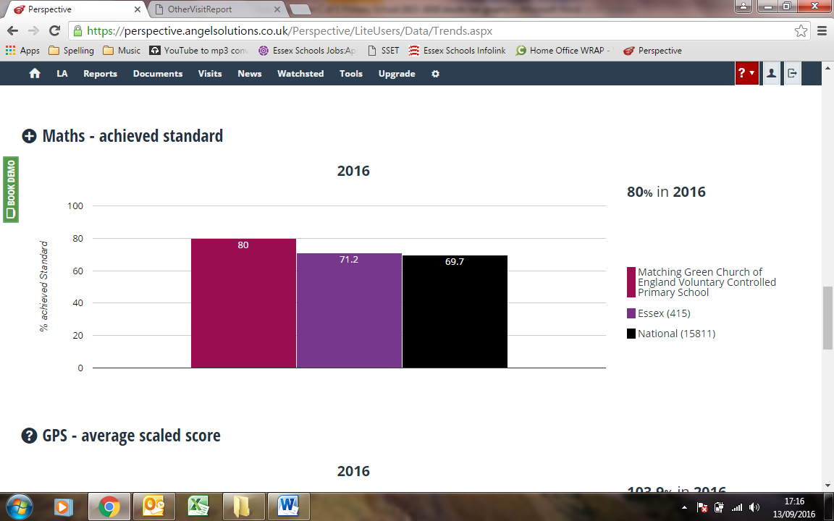

**End of Key Stage Two (Year 6) results for achieving the expected standard in Grammar, Punctuation and Spelling**

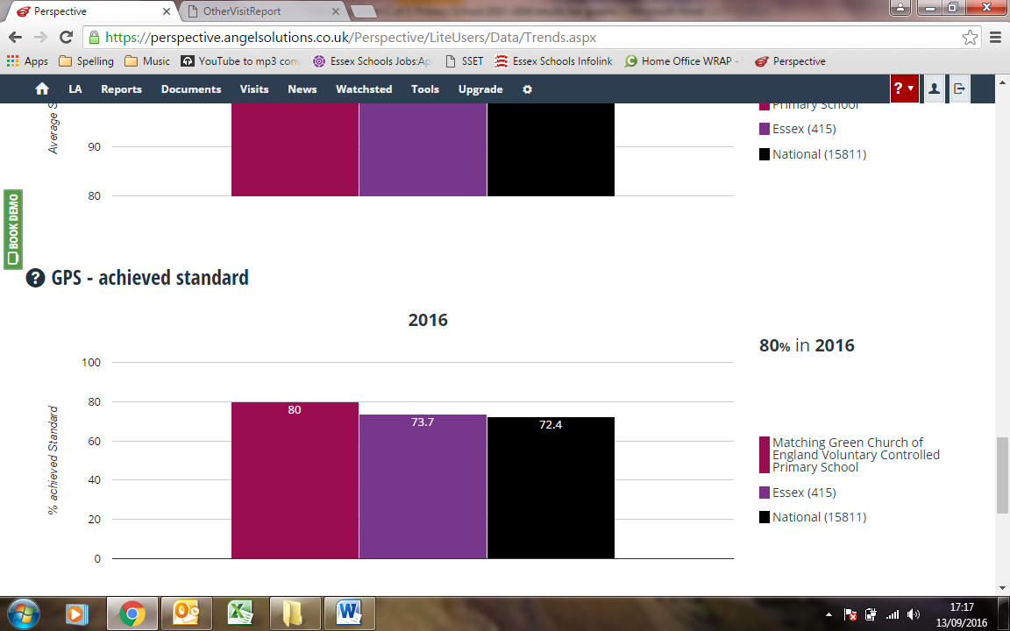

**End of Key Stage Two (Year 6) results for achieving the expected standard in Reading, Writing and Mathematics combined**

