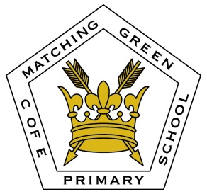

**Whats App Group Protocol**

The purpose of the group is to keep the parent community up to date on PTA and School events, e.g. to ask for volunteers to support on an event, a reminder about non-uniform day, clarification on what day the new term starts. It is also a way to ensure that new members to our school community feel welcomed and quickly gain an understanding about life at Matching Green Primary School. Other successful groups have also used this as a tool to inform parents that their child has come home with the wrong jumper/PE kit, which has then been returned.

* No photos, under any circumstances, of the children will be shared on the Whats App Groups; if photos are posted the Whats App Group Administrators will inform the school immediately.
* Any personal issues with individual children should not be discussed on the group; if this occurs the Whats App Group Administrators are to remind parents/carers that if they have any concerns/issues that these are brought to the attention of the class teacher in the usual manner.
* Whats App Adminsitrators are responsible for informing the school if they feel that non-school related topics are being discussed, or if negative topics have escalated unnecessarily.
* If at any time the protocols are not being followed appropriately then the School will ask for the group to be disbanded.

Name……………………………………………………………

Signed……………………………………………………………

Date………………………………………………………………